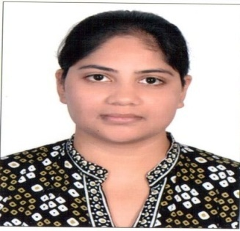
Permanent Address: Raghunath Niwas Nau Mehala, Gwalior(M.P.) - 474003
Phone: +91-9165915156
Email: mathurankita54@gmail.com

OBJECTIVE
To succeed in an environment of growth and excellence and earn a job in corporate sector which provide me job satisfaction and self development and help me achieve personal as well as organizational goals.

PROFESSIONAL QUALIFICATION
- Pursuing one year LL.M. from Amity Law School, AUMP ,Gwalior with specialization in Corporate Law.
- Graduation in LL.B(Hons) from Jiwaji University, Gwalior(M.P.)
.

ACADEMIC QUALIFICATION

- LL.B(Hons.) from Jiwaji University,Gwalior(M.P.) with 65.36%
- HSC from Blue Birds School,Gwalior, M.P. Board with 58.6%
- SSC from Blue Birds School, Gwalior, M.P. Board with 55.3%

COMPUTER INTELLECT

• Skills: Microsoft Excel, MSword, MS office.

LANGUAGE SKILLS

• English
• Hindi
• French (Basics)

COMMUNITY SERVICE

• Spent time with children and an old age people at an Orphanage in Gwalior.

EXTRACURRICULAR & CO-CURRICULAR ACTIVITIES

- Worked as an active volunteer in various legal-aid camps organized by Institute of Law, Gwalior.
- Awarded as a Best Orator In School

HOBBIES

  - To spent my time with the children and old age people of the orphanages.
  - Listening music.

STRENGTH

- Self monitoring
- Diligent
- Innovative
- Patience

PERSONAL DETAILS

- Name - Ankita Mathur
- Father's Name - Bharat Behari Mathur
- DOB - 15-12-1987
- Gender - Female

Declaration

I hereby declare that all the above information is true to the best of my knowledge and belief.

Ankita Mathur

